Team members and contributions:
Andrew Paettie: establishing framework and expanding on it
Jackson Duke: testing / bugfixes
Tyler Justice: graphics

Program Description:
A basic 2-D sidescroller created using JAVA. Fly the helicopter through the level trying to collect as many rings as possible while avoiding any obstacles along the way. Reach and land safely past the finish line to advance to the next level. Beat all levels and you win!
Program Architecture:
The program features an abstract class sprite, which allows for quickly making new game objects. A sprite has an x and y representing its position with respect to the gameworld , an xspeed, and a collision shape. The image can be handled by the sprite class or by AnimationUtils.
AnimationUtils is basically a way to handle animation based on how many times the program has been updated since the animation started. It is built in one of two ways. The first constructor takes the number of frames, a string representing the common path and name of the animation's image frames, an int [] representing the numbers after each frame's common name, a string representing the file extension of the image frames, an int representing the animation delay (in number of updates), and an enumeration representing if this animation plays once or loops.
The program starts off by building the game window in its own thread. The use of an int array representing the frame number allows reuse of frames, especially in the helicopter turning animation. This constructor will load files for each instance of this animation, so is best for when there is only one instance of this animation. However, for objects with many instances of the animation present, such as birds, there is another constructor which does not load and store the images, but rather only stores the index of the image which should be played. This means that when this constructor is called, the frames of animation should be handled elsewhere, statically. This reduces the potential memory footprint of the application, as only one copy of the animation's frames has to be stored in memory.
There is a level object which contains the components of the gameworld (except the helicopter) which is build once the UI is built. To build a level, it is loaded from a file. The level file is basically just a plaintext file which lists the position of the level's fixed objects, such as the ground, rings, and trees. The syntax is essentially the command followed by parentheses with the position. For example, the line "tree(200,370)" creates a tree at x position 200, y position 370. The ground is defined by a (long) list of x points and y points. These ground points are read into an array and used to generate a path used for collision detection and also to draw the ground texture along the ground's path. Birds are then randomly generated off screen. There is no need for these birds to move through the entire level, so their position is always relative to the canvas, rather than the level world. The fixed objects, such as the ground and trees are drawn onto an image representing the whole level. Subimages of this image will be drawn repeatedly as the helicopter moves through the level. When the helicopter gets to the point GAME_WIDTH/2, the level's currentX value moves at the same speed as the helicopter, so even though the helicopter is stationary with regards to the canvas, it appears as if it is moving through the level. The level stops moving when it reaches the point “levelLength – GAME_WIDTH/2” and the heli is free to move across the canvas.
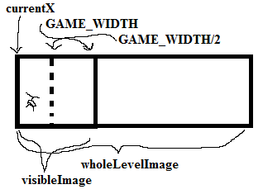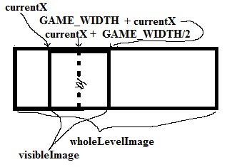

Once the level is loaded, other objects in the game, such as the helicopter and the explosions are initialized. The helicopter is set up such that it has an x and a canvasX. Its x position represents its position in the gameworld, which is important for collision detection, while the canvasX represents where it is drawn on the canvas. There are also several animations related to the helicopter which must be initialized, including its turning animations, and explosion animations.
After all of the gameworld objects are initialized, it is time to start building the UI. The main runner for the program HeliGameMain is actually a JFrame, so this is built. Then various panels are created and added to this JFrame. There is an instrument panel, designed as an inner class of HeliGameMain, InstrumentPanel, which presents speed, score, and throttle information graphically to the user. There is also an options panel with buttons to pause, play, stop, or bring up a help menu. This is also designed as an inner class of HeliGameMain, OptionsPanel. The help menu is also an inner class of HeliGameMain, HelpMenu. It contains information on the controls and objective of the game, as well as a button to play the game. There is also a Canvas, gameCanvas, designed as an inner class of HeliGameMain so that it can easily access the game objects. This is where the game is drawn. This canvas utilizes active rendering, using double buffering to prevent flickering caused by drawing directly onto the screen. The gameCanvas contains an offscreen image, offImage which it draws to to render the game. It also implements KeyListener, so that it can receive input from the keyboard. Once all of this is construced the game is set to PAUSED, and the game's thread is started by start().
When started, the game's loop will run in its own thread. The loop will run until the gameState is set to GAMEOVER or WIN, and the process is relatively simple. First it takes a measurement of the time using System.nanotime(). It calls updateGame(), which updates the position of all of the level's objects and then performs collision detection. Then the game is drawn based on these updated positions. Then it takes another measurement of the time, which is used to calculate how long to sleep to keep at the set number of updates per second. This sleep time allows for other threads to use the CPU, such as the EDT, which prevents input lag. This process continues until the game is won or lost, at which time a message will be drawn on the game to relay that the user has won or lost.
Challenges:

